Date

Dear (name),

With your birthday coming up, we’re sending you our best wishes for another happy and healthy year ahead. We’d also like to remind you how important it is to maintain your health and your ability to save others—and yourself—by scheduling your NFPA 1582 annual physical during the month of your birthday.

This comprehensive exam is provided at no charge to our firefighters and EMS personnel, and it’s a requirement of your continued service. The NFPA physical can assess and identify potentially fatal underlying medical conditions as well as preventable risks to your physical, behavioral and emotional health. It has already helped to prevent many line-of-duty deaths among first responders, and it could save your life too.

The NFPA physical takes about three hours, but it can give you immeasurable confidence afterward—you’ll feel secure knowing that the public and your fellow first responders can count on you. And if a health issue is found, you may be able to continue to work during treatment, or return to the line after treatment. But no matter what, your personal safety is our first priority.

As your birthday nears, give yourself the gift of good health. Please reach out to me or to (name/title) to schedule or learn more about the NFPA annual physical. And thank you for being a valued member of our first responder team.

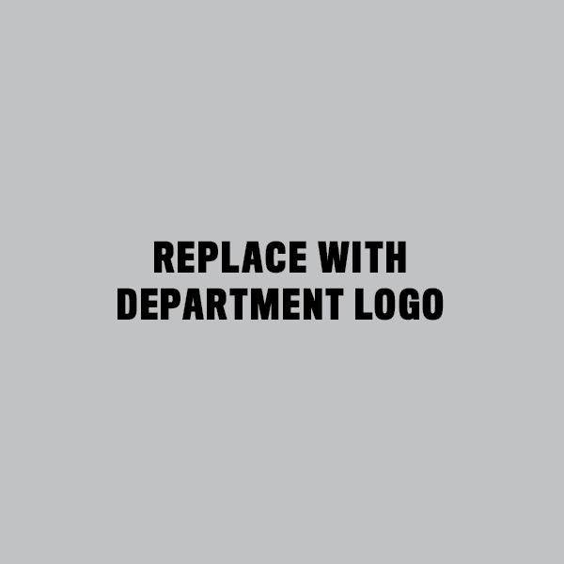
Sincerely,

Name/title
Name of fire company

